The navigation on the website can be confusing, so follow the steps below.

1. Go to http://www.oneness.vu.lt/.
This is a program for people who want to begin learning Estonian, Finnish, Lithuanian, Polish or Portuguese. It has been financed in part by the European Union and other partners, but, for some reason, it has not been fully developed by its co-authors. Thus, some links or exercises may not work; still, there is plenty of TEXT and AUDIO material. I think that the website can serve you well (there are no ads!).
2. Go to http://www.oneness.vu.lt/en/, read the page and watch a short Learners Guide movie.
3. Then open http://www.oneness.vu.lt/pl/:
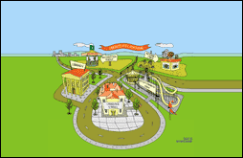
You will see the picture above. There are five "places" click the "Language School". You will check the other places later, but the "Language School" is your core.
4. Now you will see the picture below:
- Choose lesson -

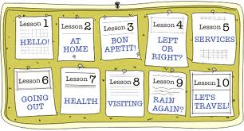

5. You will be choosing lessons 1-10 using the box on your right. So your next screen will appear as follows:
- Lesson 1-

Contents |  |  | Vocabulary |  |  | Grammar |  |  | Reading |  |  | Listening |  |  | Speaking |  |  | Writing |  |  | Exercises
and so on….

